Name: Mriganka Patra

Email: [mriganka.patra@cognizant.com](mailto:mriganka.patra@cognizant.com)

Emp ID: 2415820

Day 18

Sprint 1 Submission

Task 1.3: As an admin, I want to create Users with specific access levels so that only autorized roles can access or edit data.

1. Goto setup > home
3. 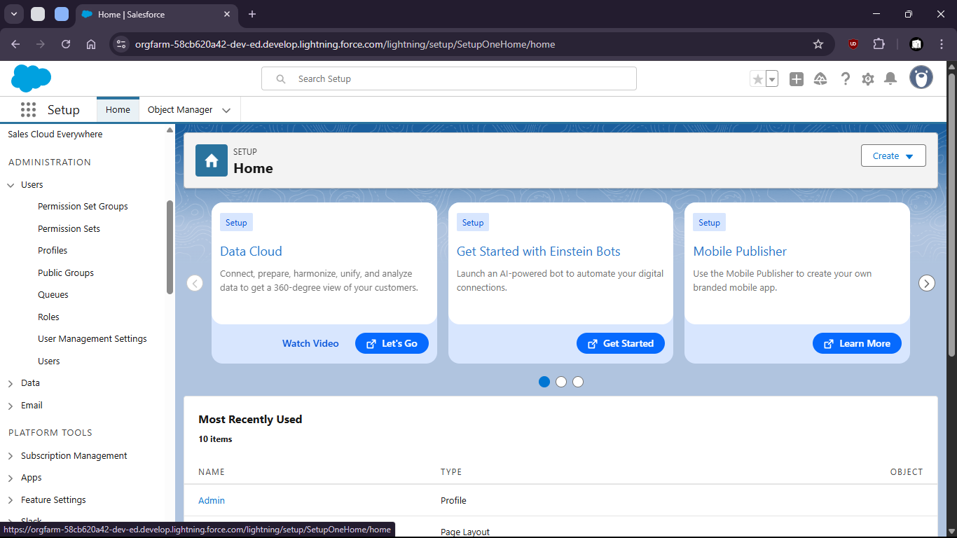
5. Open profiles and create profiles
7. 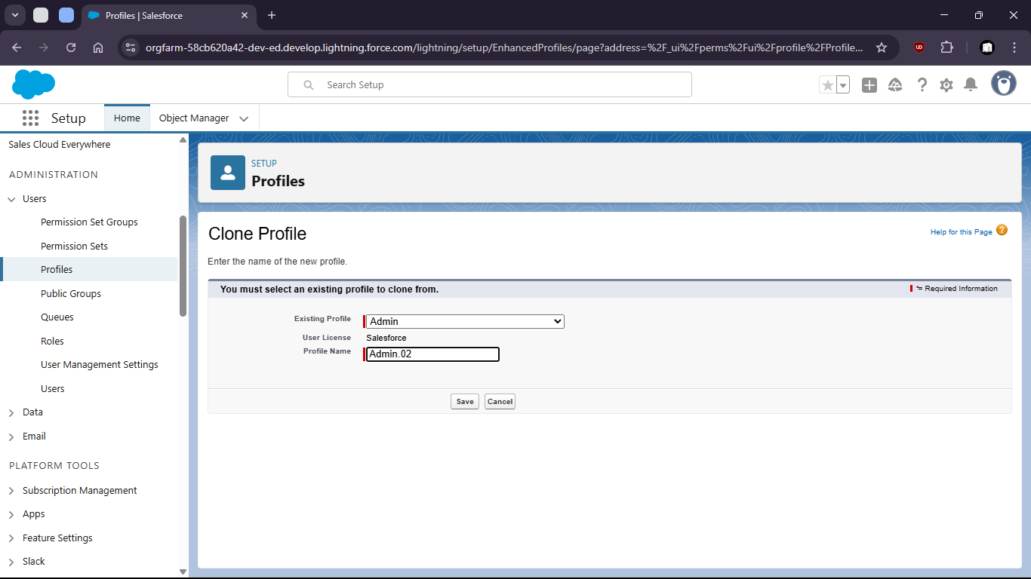

10. Limit Access (field level security)
12. 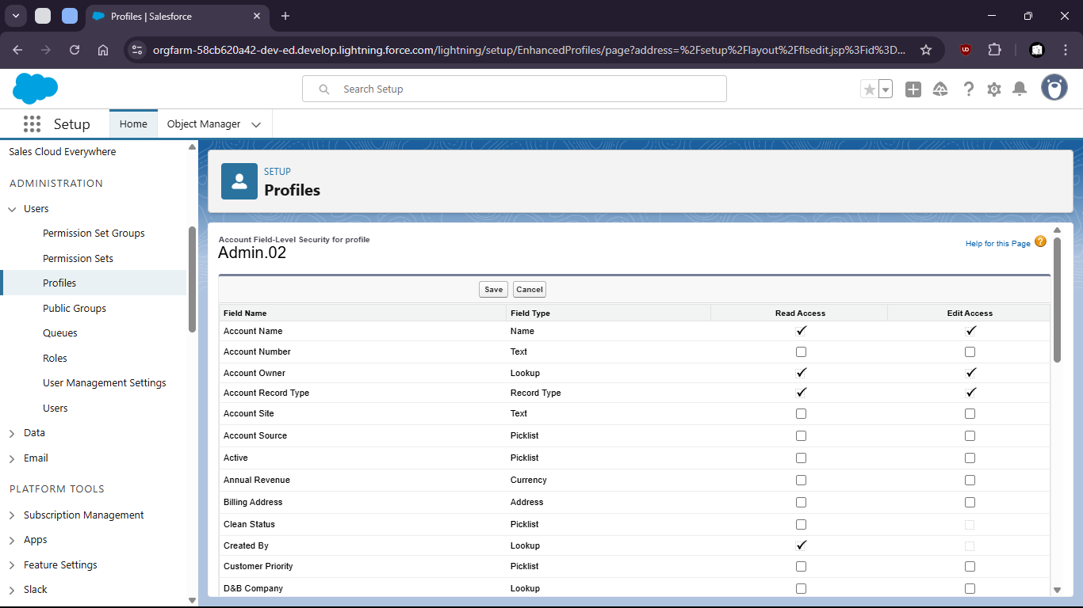
13. Set standard object Permissions
15. 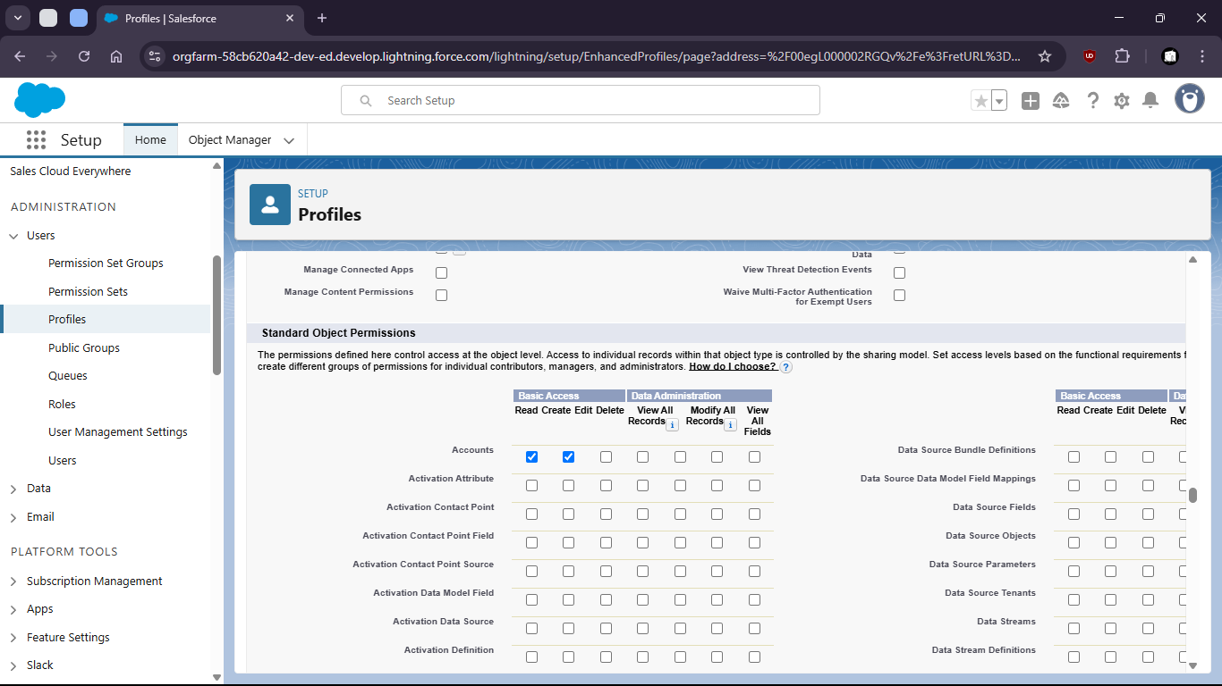
17. Add to permission sets
19. 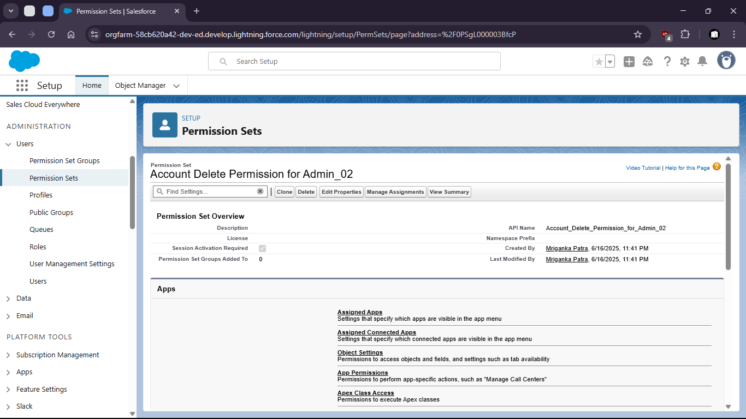
20. Change object settings
22. 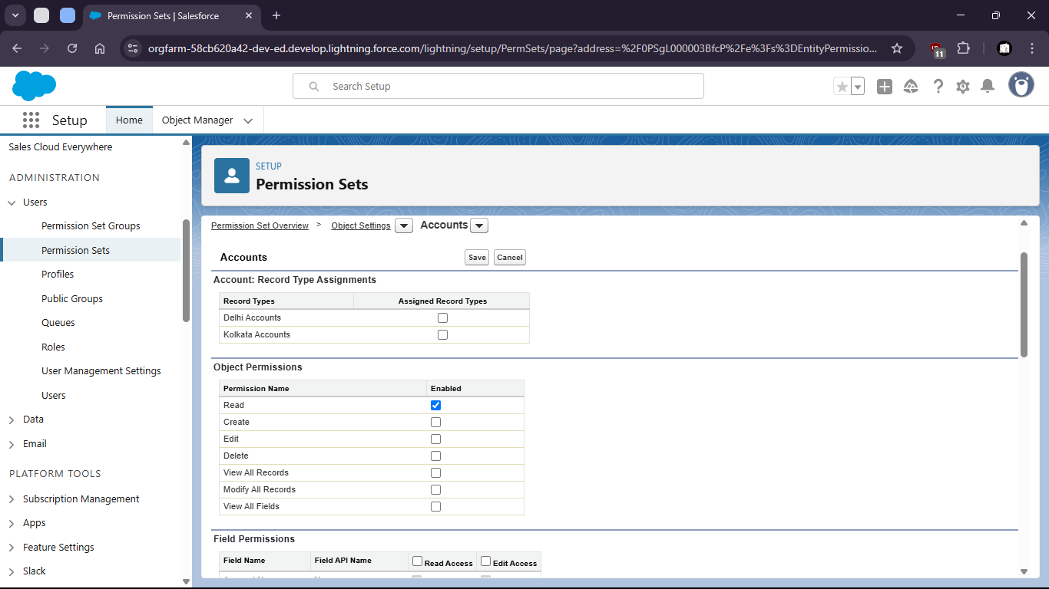
23. Create new User
25. 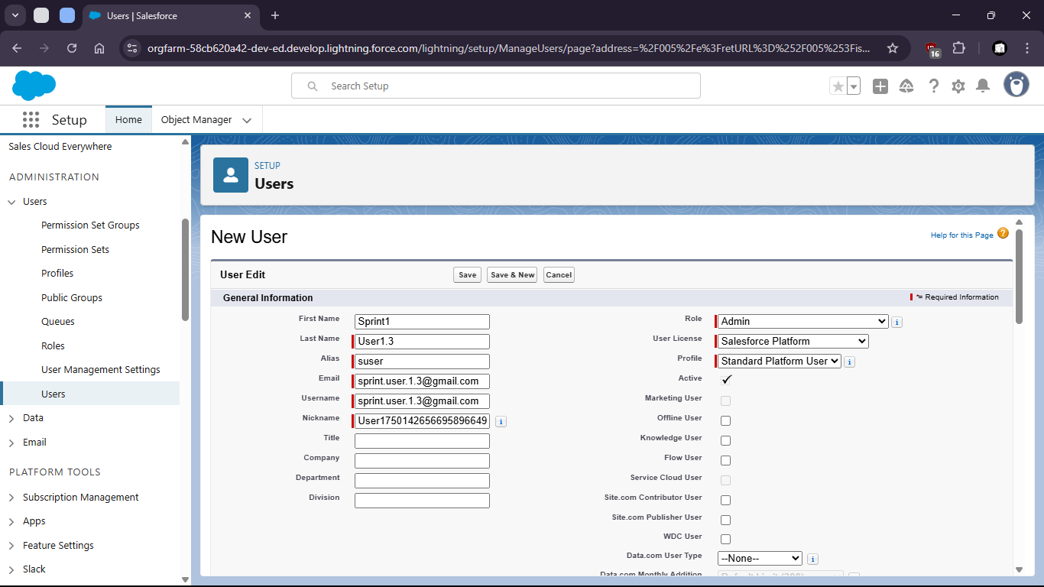
26. Assign user to Permission sets
28. Assigning User to Roles can also limit access levels
30. 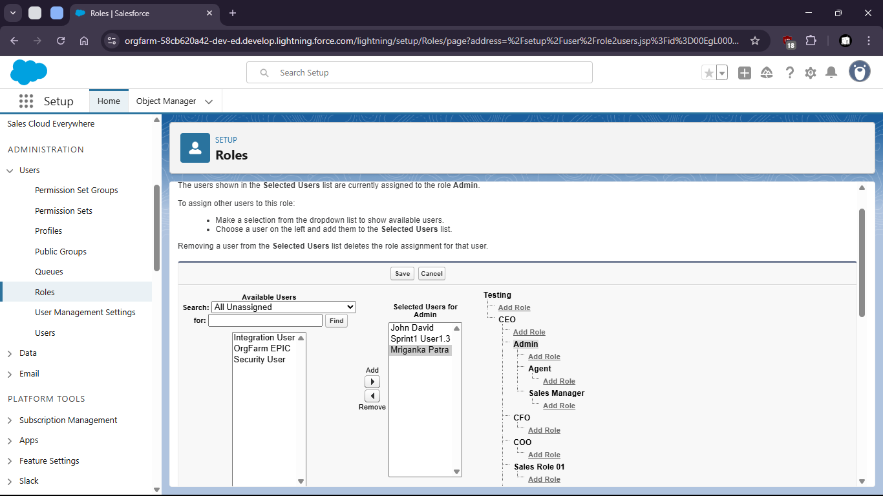
31. Where the access is restricted to upper levels